Ch. 1 Appendix

Lea Pollack and Michael Culshaw-Maurer

23 September, 2020

# Latency post predator cue

## Model description

## latency ~ 1 + treatment + trial + (1 | group_ID) + (1 | tank)   
## hu ~ 1 + treatment + trial + (1 | group_ID) + (1 | tank)

##   
## Family: hurdle_negbinomial   
## Link function: log

## Marginal effects plots

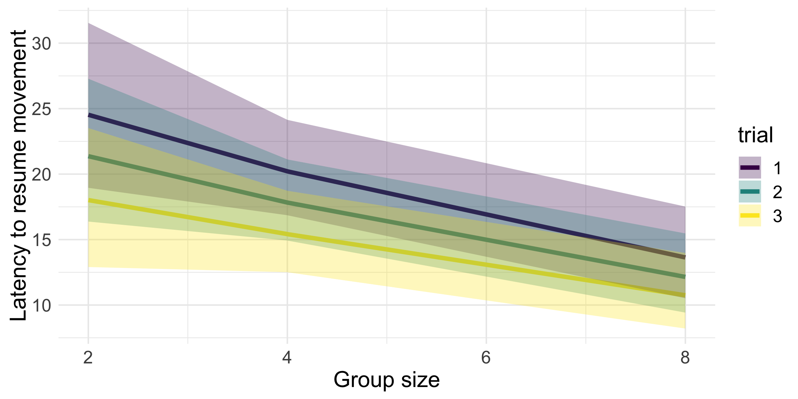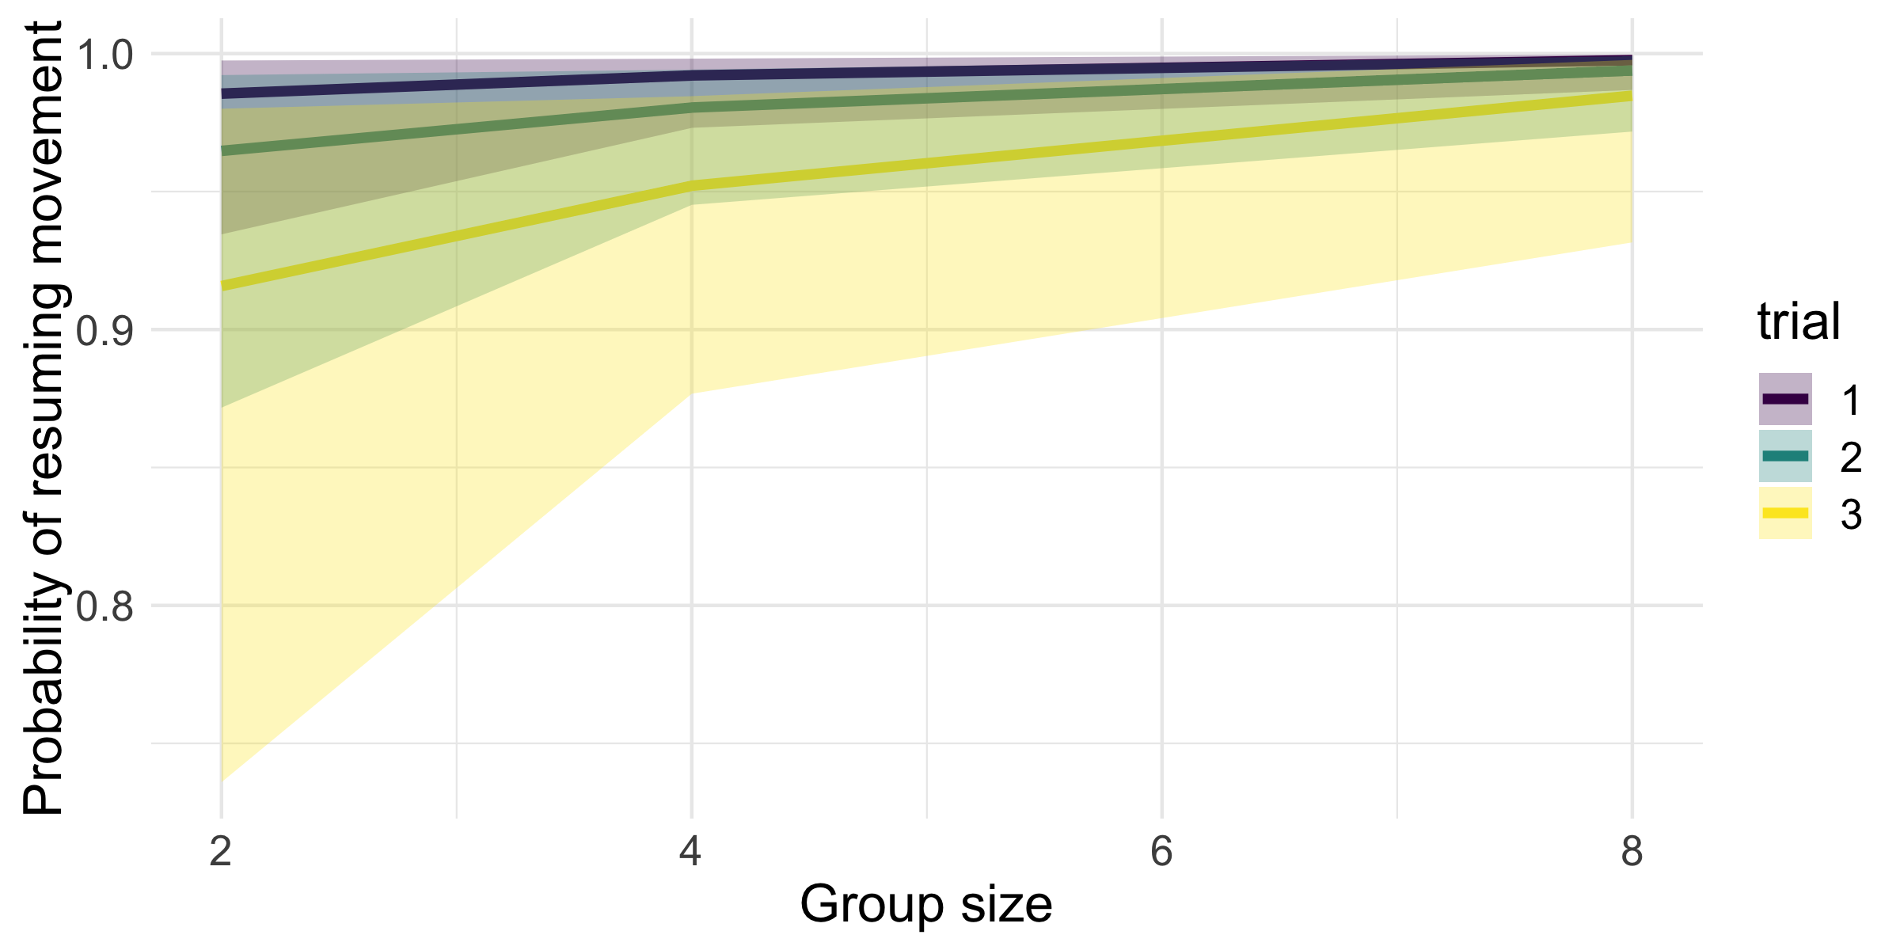

## ICC table

|  |  |  |  |
| --- | --- | --- | --- |
| model_name | median_icc | ci_2.5 | ci_97.5 |
| lat_pred | 0.5987 | 0.3742 | 0.7864 |

## Parameter table

|  |  |  |  |  |
| --- | --- | --- | --- | --- |
| variable | median | hdi_2.5 | hdi_97.5 | overlap_zero |
| b_hu_Intercept | -4.532 | -7.056 | -2.209 | FALSE |
| b_hu_treatment | -0.2983 | -0.6936 | 0.07054 | TRUE |
| b_hu_trial | 0.9188 | 0.4639 | 1.455 | FALSE |
| b_Intercept | 3.526 | 3.147 | 3.908 | FALSE |
| b_treatment | -0.1041 | -0.1689 | -0.04004 | FALSE |
| b_trial | -0.1173 | -0.1925 | -0.04367 | FALSE |
| shape | 1.368 | 1.219 | 1.528 | FALSE |

# 

# Latency known food

## Model description

## latency ~ 1 + treatment + trial + (1 | group_ID) + (1 | tank)   
## hu ~ 1 + treatment + trial + (1 | group_ID) + (1 | tank)

##   
## Family: hurdle_negbinomial   
## Link function: log

## Marginal effects plots

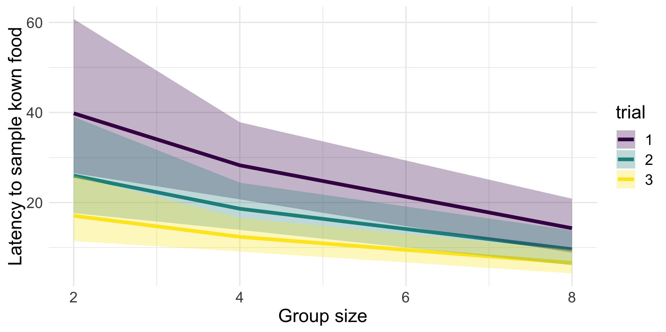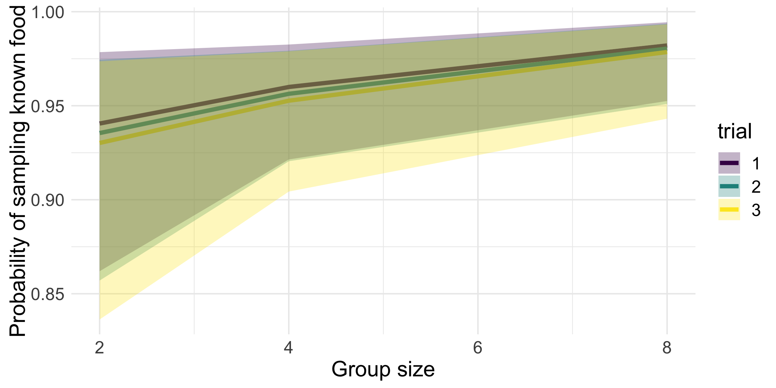

## ICC table

|  |  |  |  |
| --- | --- | --- | --- |
| model_name | median_icc | ci_2.5 | ci_97.5 |
| lat_known | 0.6654 | 0.2938 | 0.9209 |

## Parameter table

|  |  |  |  |  |
| --- | --- | --- | --- | --- |
| variable | median | hdi_2.5 | hdi_97.5 | overlap_zero |
| b_hu_Intercept | -2.438 | -3.918 | -0.9757 | FALSE |
| b_hu_treatment | -0.2052 | -0.4437 | 0.02105 | TRUE |
| b_hu_trial | 0.0924 | -0.2646 | 0.459 | TRUE |
| b_Intercept | 4.476 | 3.84 | 5.135 | FALSE |
| b_treatment | -0.196 | -0.3099 | -0.086 | FALSE |
| b_trial | -0.4544 | -0.5741 | -0.3339 | FALSE |
| shape | 0.5093 | 0.4214 | 0.5945 | FALSE |

# 

# Latency novel food

## Model description

## latency ~ 1 + treatment + novel_food + (1 | group_ID) + (1 | tank)   
## hu ~ 1 + treatment + novel_food + (1 | group_ID) + (1 | tank)

##   
## Family: hurdle_negbinomial   
## Link function: log

## Marginal effects plots

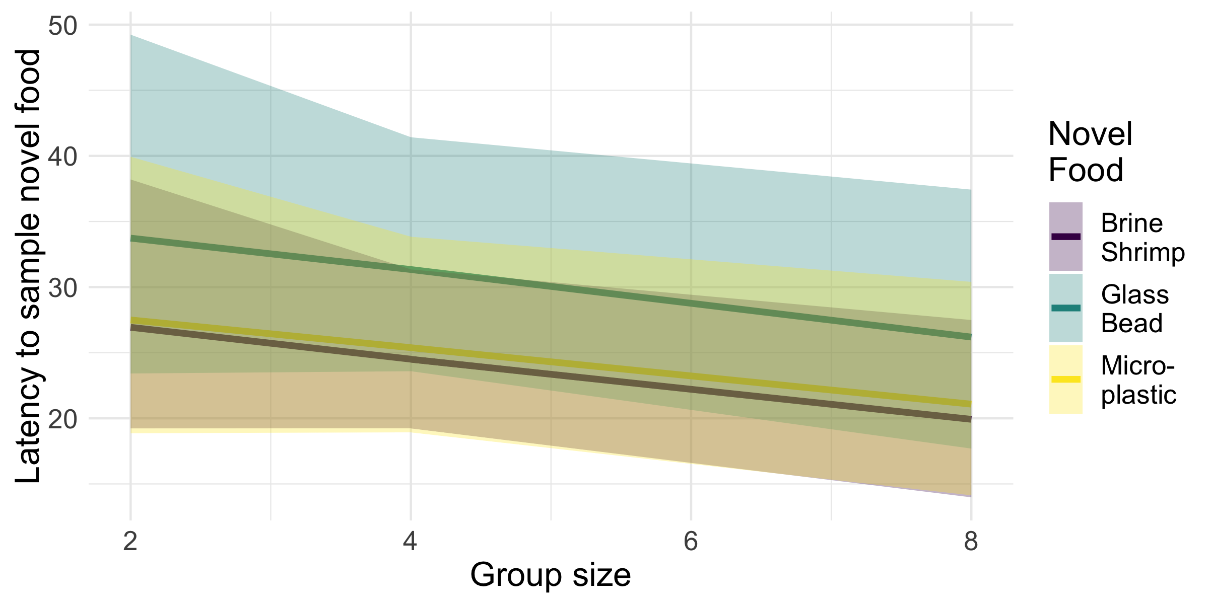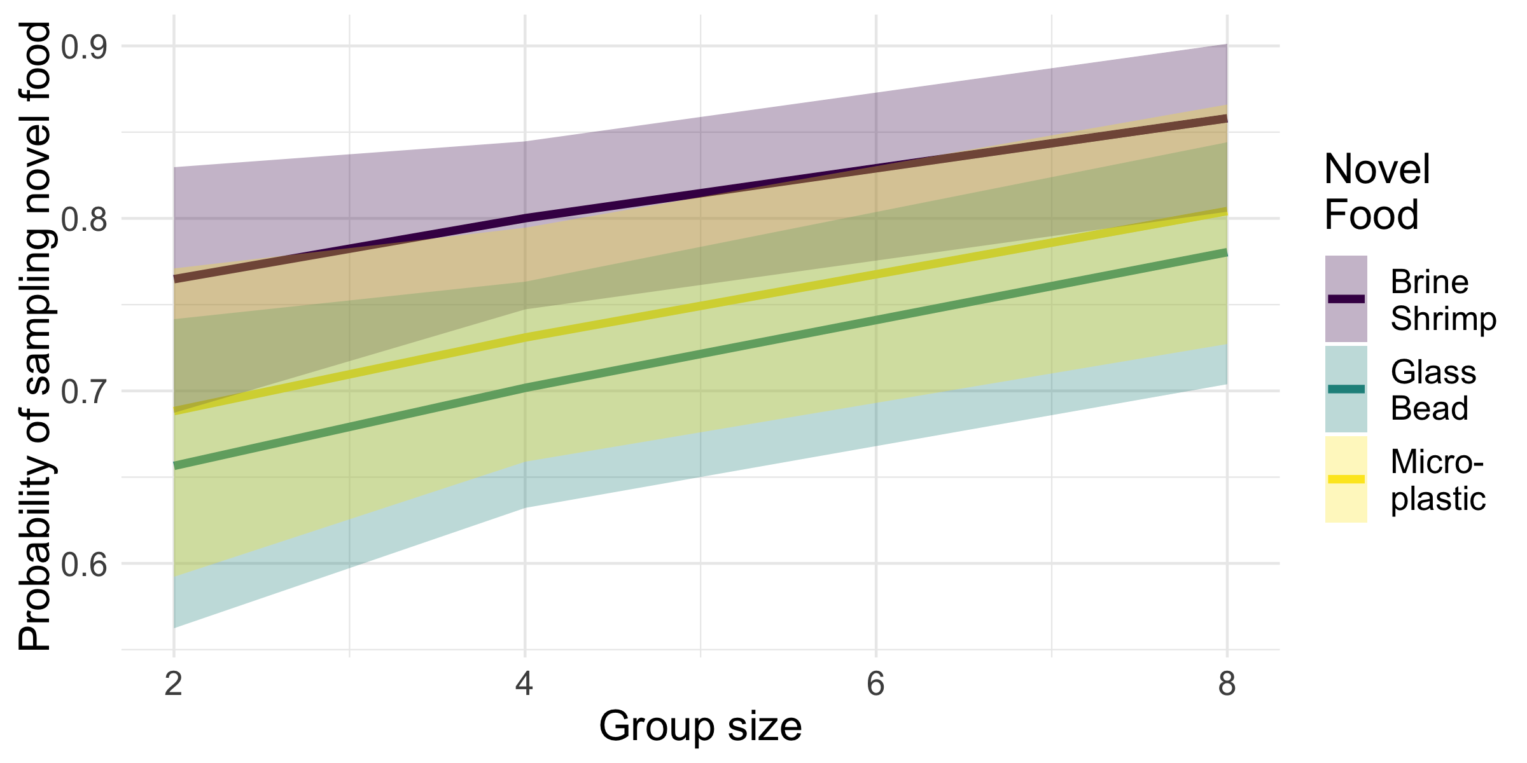

## Pairwise contrast tables

### Latency

|  |  |  |  |  |
| --- | --- | --- | --- | --- |
| contrast | Median Odds Ratio | 2.5% CI | 97.5% CI | Overlaps 1 |
| Bead / Plastic | 1.309 | 0.9515 | 1.7 | TRUE |
| Brine / Bead | 0.668 | 0.5131 | 0.8398 | FALSE |
| Brine / Plastic | 0.874 | 0.6665 | 1.119 | TRUE |

### Hurdle

|  |  |  |  |  |
| --- | --- | --- | --- | --- |
| contrast | Median Odds Ratio | 2.5% CI | 97.5% CI | Overlaps 1 |
| Bead / Plastic | 0.863 | 0.567 | 1.234 | TRUE |
| Brine / Bead | 1.672 | 1.146 | 2.264 | FALSE |
| Brine / Plastic | 1.446 | 0.9473 | 2.015 | TRUE |

## ICC table

|  |  |  |  |
| --- | --- | --- | --- |
| model_name | median_icc | ci_2.5 | ci_97.5 |
| lat_novel | 0.4235 | 0.009088 | 0.7537 |

## Parameter table

|  |  |  |  |  |
| --- | --- | --- | --- | --- |
| variable | median | hdi_2.5 | hdi_97.5 | overlap_zero |
| b_hu_Intercept | -0.9728 | -1.512 | -0.4418 | FALSE |
| b_hu_novel_foodBead | 0.5321 | 0.1875 | 0.8749 | FALSE |
| b_hu_novel_foodPlastic | 0.3858 | 0.01431 | 0.7737 | FALSE |
| b_hu_treatment | -0.1029 | -0.194 | -0.0141 | FALSE |
| b_Intercept | 3.581 | 3.105 | 4.088 | FALSE |
| b_novel_foodBead | 0.4034 | 0.168 | 0.6588 | FALSE |
| b_novel_foodPlastic | 0.1347 | -0.1192 | 0.3987 | TRUE |
| b_treatment | -0.07574 | -0.1623 | 0.009784 | TRUE |
| shape | 0.498 | 0.4156 | 0.582 | FALSE |

# 

# Mean Group Novel Latency

## Model description

## novel_mean_lat ~ 1 + known_mean_lat_c + pred_mean_lat_c + treatment + trial + (1 | group_ID) + (1 | tank)   
## hu ~ 1 + known_mean_lat_c + pred_mean_lat_c + treatment + trial + (1 | group_ID) + (1 | tank)

##   
## Family: hurdle_gamma   
## Link function: log

## Parameter table

|  |  |  |  |  |
| --- | --- | --- | --- | --- |
| variable | median | hdi_2.5 | hdi_97.5 | overlap_zero |
| b_hu_Intercept | -2.22 | -7.211 | 2.433 | TRUE |
| b_hu_known_mean_lat_c | -0.06687 | -1.022 | 0.7536 | TRUE |
| b_hu_pred_mean_lat_c | 0.4786 | -0.287 | 1.334 | TRUE |
| b_hu_treatment | -1.213 | -2.624 | -0.1941 | FALSE |
| b_hu_trial | 0.4993 | -0.6014 | 1.814 | TRUE |
| b_Intercept | 3.237 | 2.715 | 3.787 | FALSE |
| b_known_mean_lat_c | 0.1451 | -0.005101 | 0.2988 | TRUE |
| b_pred_mean_lat_c | 0.04932 | -0.1255 | 0.2402 | TRUE |
| b_treatment | -0.01781 | -0.1013 | 0.06376 | TRUE |
| b_trial | 0.06781 | -0.09718 | 0.2291 | TRUE |
| shape | 1.246 | 0.9957 | 1.523 | FALSE |

# 

# Per-Capita Chases

## Model description

## percap_chases ~ 1 + treatment + assay * trial + (1 | group_ID) + (1 | tank)   
## hu ~ 1 + treatment + assay * trial + (1 | group_ID) + (1 | tank)

##   
## Family: hurdle_gamma   
## Link function: log

## Marginal effects plots

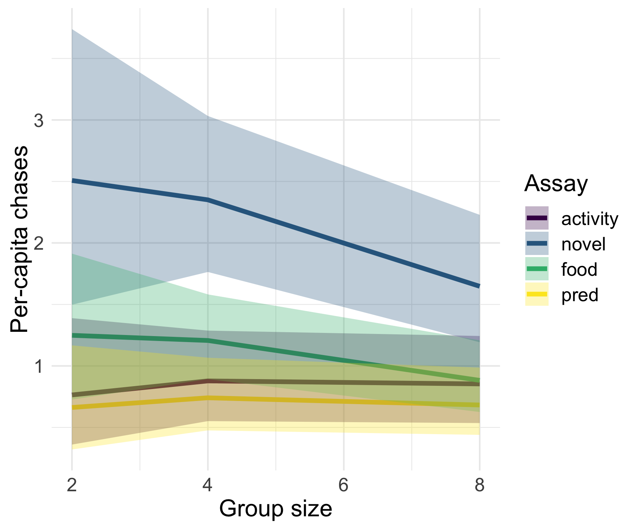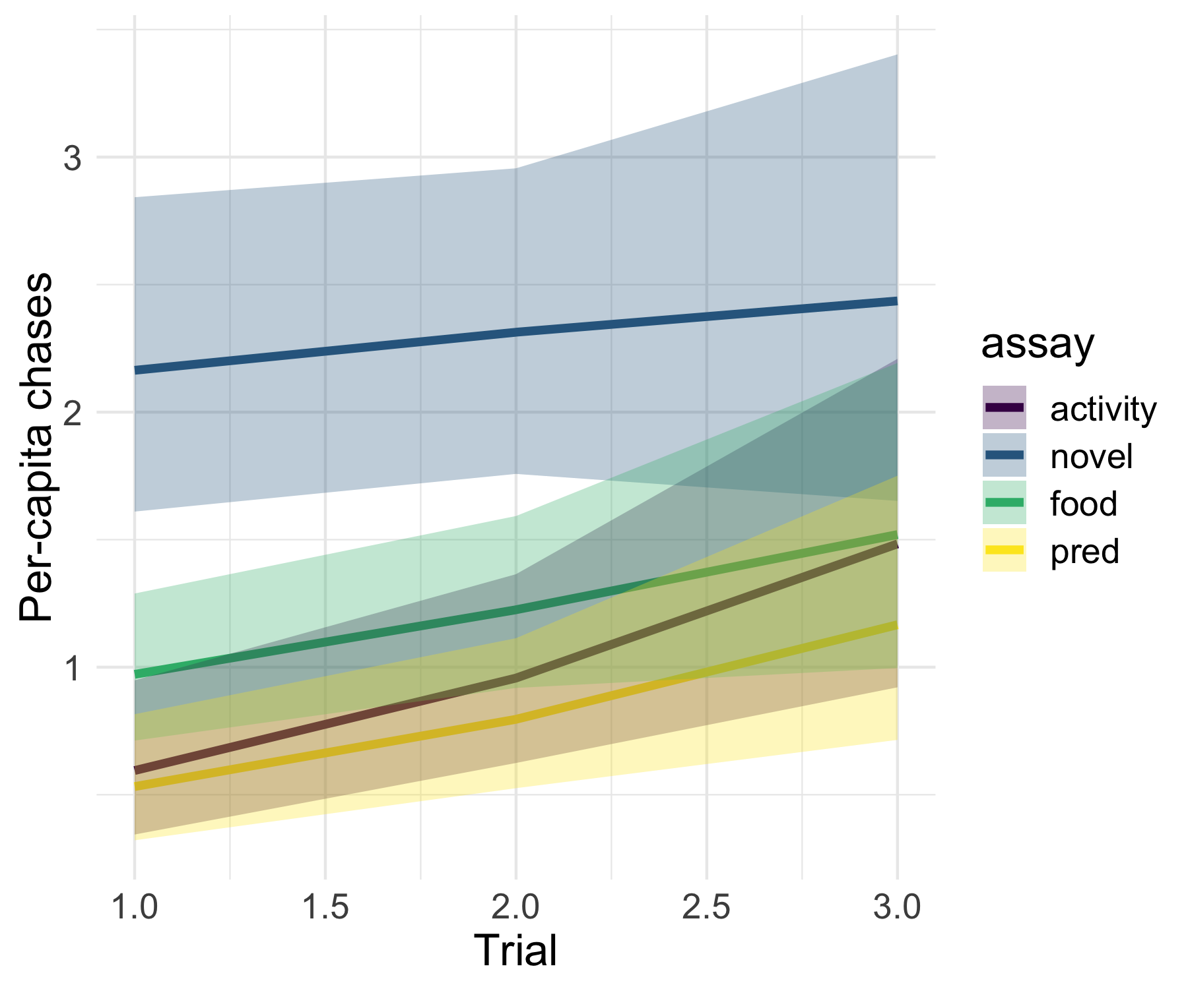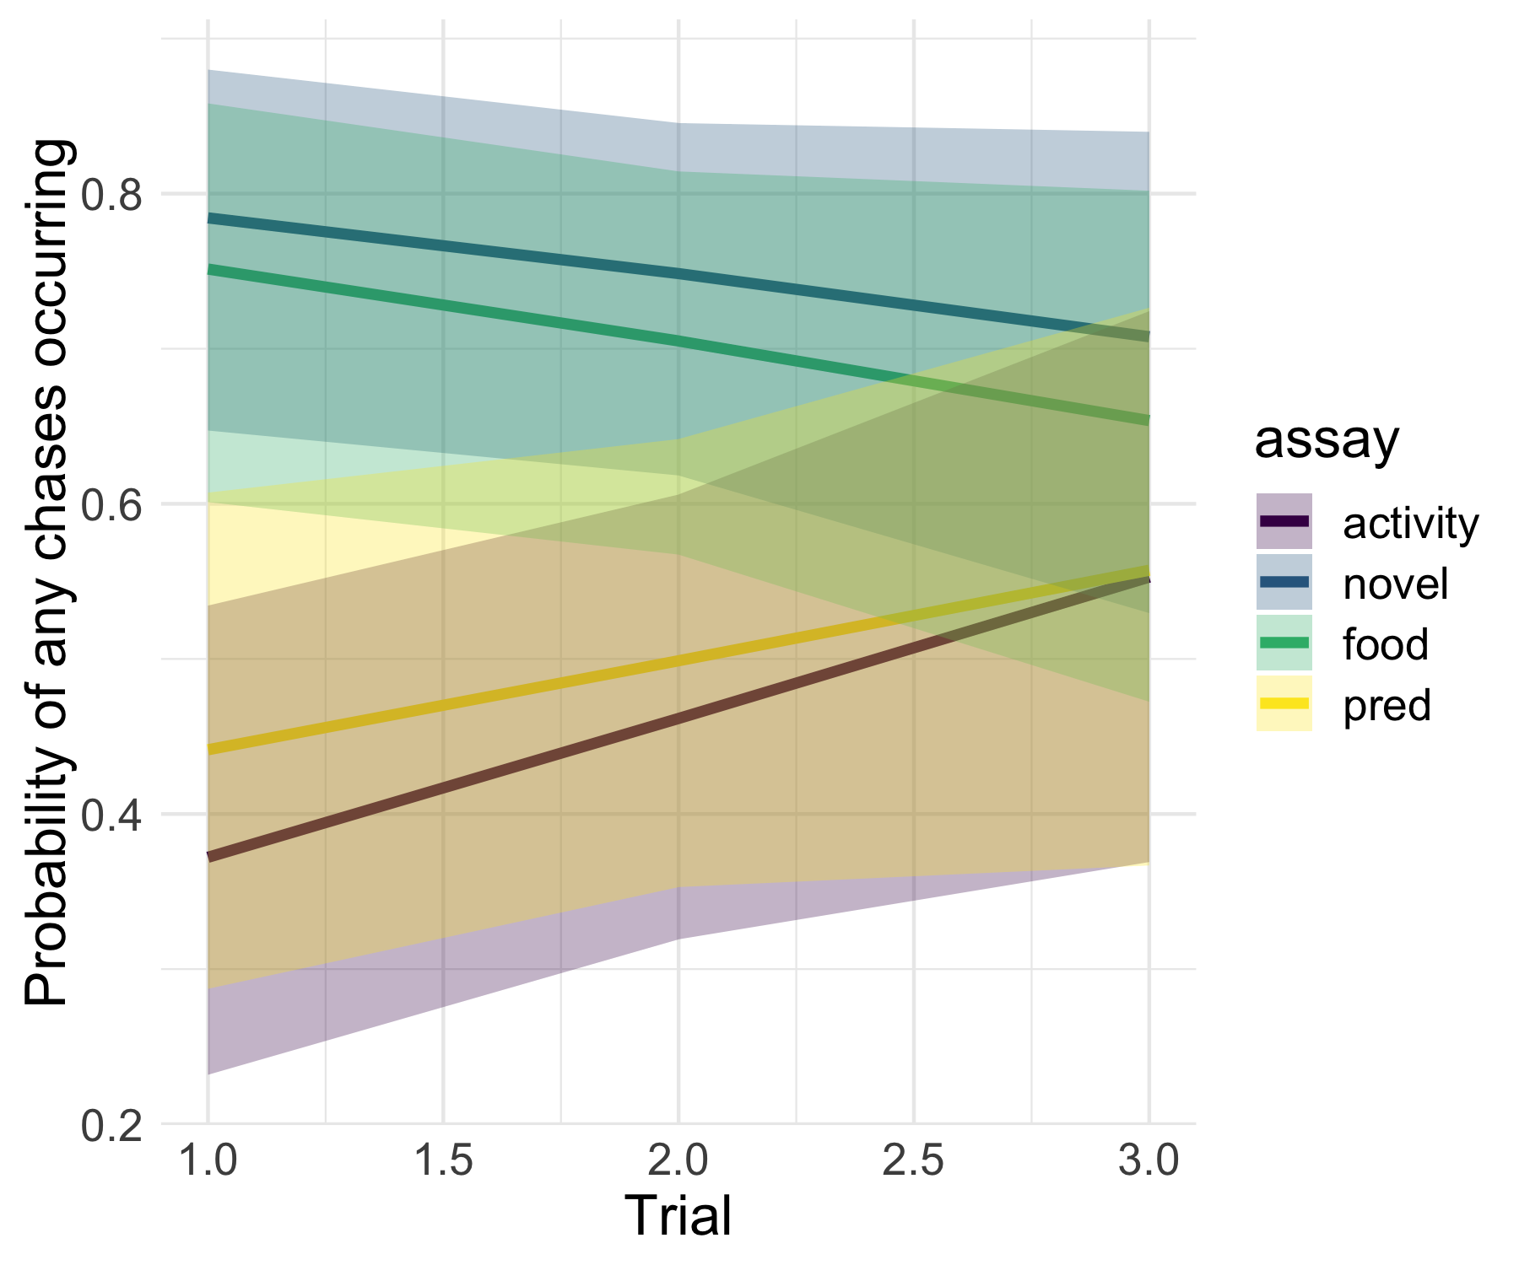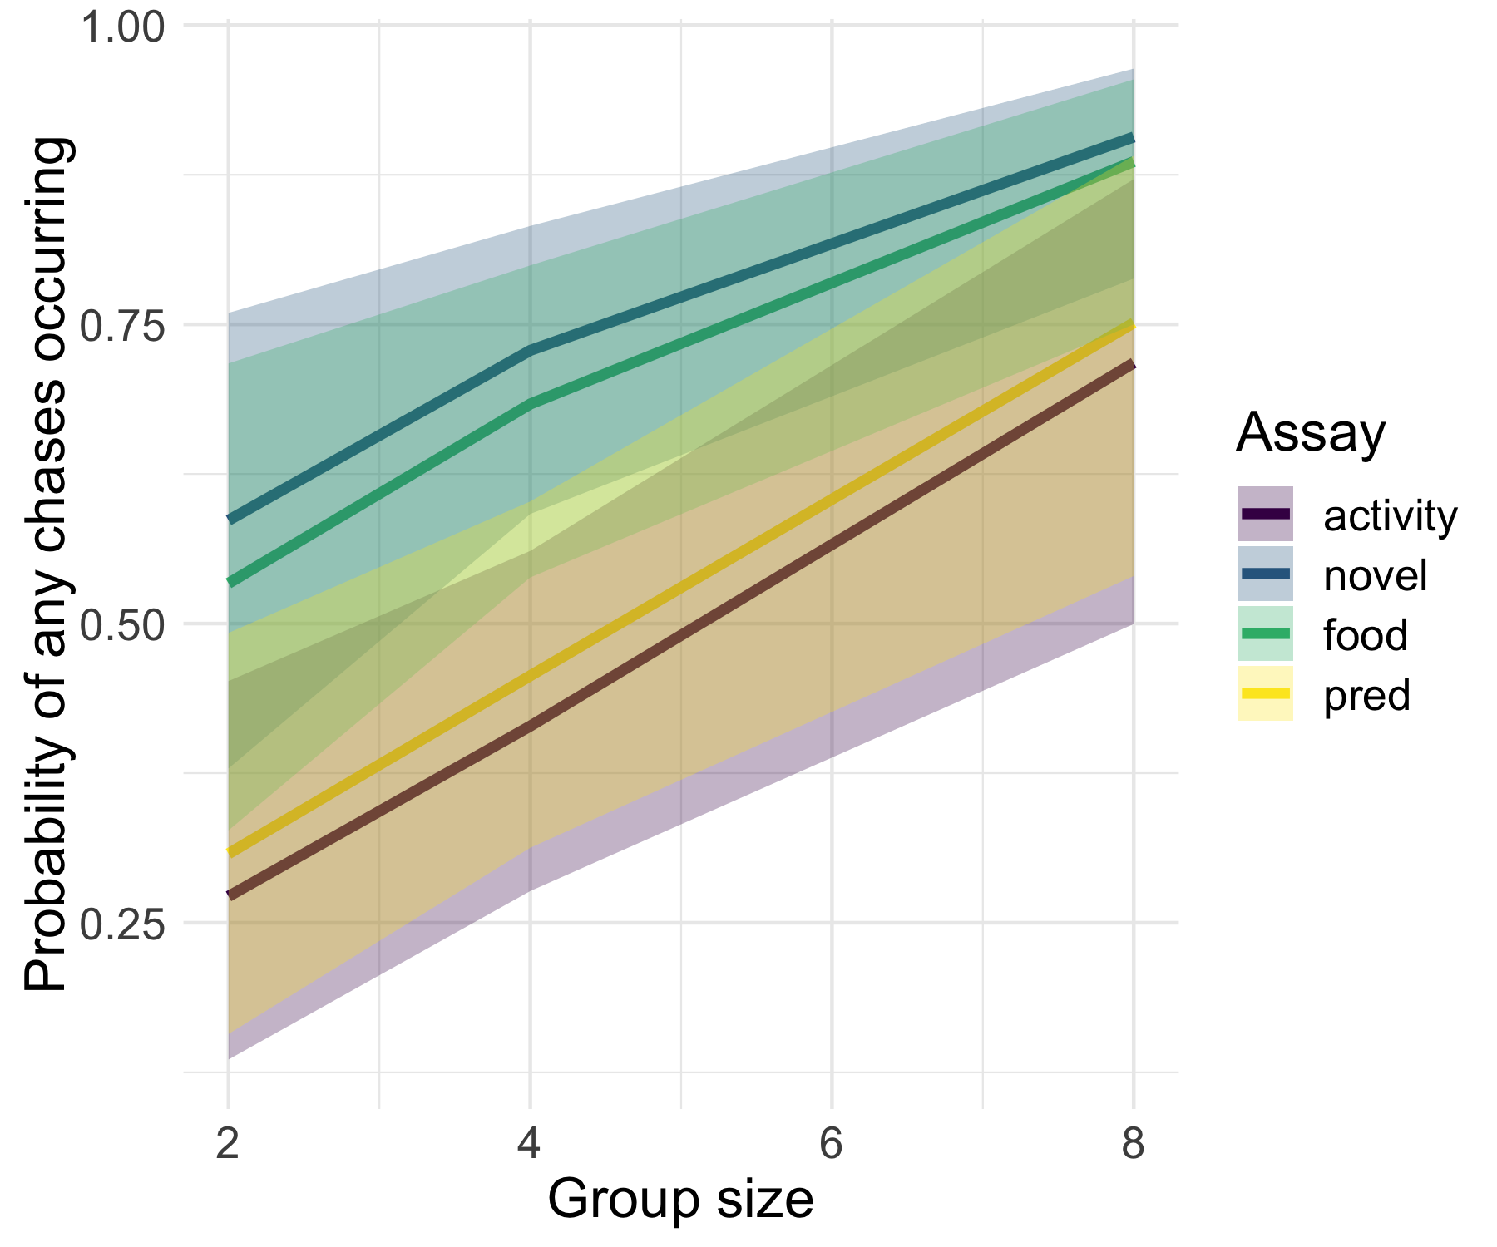

## Parameter table

|  |  |  |  |  |
| --- | --- | --- | --- | --- |
| variable | median | hdi_2.5 | hdi_97.5 | overlap_zero |
| b_assayfood | -0.2374 | -0.6808 | 0.231 | TRUE |
| b_assayfood:trial | 0.03263 | -0.1904 | 0.2507 | TRUE |
| b_assaynovel | 0.6986 | 0.2509 | 1.154 | FALSE |
| b_assaynovel:trial | -0.1476 | -0.3667 | 0.07177 | TRUE |
| b_assaypred | -0.3033 | -0.7716 | 0.1776 | TRUE |
| b_assaypred:trial | 0.01956 | -0.2019 | 0.2572 | TRUE |
| b_hu_assayfood | -2.225 | -3.351 | -1.09 | FALSE |
| b_hu_assayfood:trial | 0.599 | 0.06097 | 1.154 | FALSE |
| b_hu_assaynovel | -2.385 | -3.555 | -1.282 | FALSE |
| b_hu_assaynovel:trial | 0.572 | -0.002741 | 1.131 | TRUE |
| b_hu_assaypred | -0.4154 | -1.582 | 0.6402 | TRUE |
| b_hu_assaypred:trial | 0.135 | -0.3973 | 0.6888 | TRUE |
| b_hu_Intercept | 2.307 | 0.898 | 3.689 | FALSE |
| b_hu_treatment | -0.3209 | -0.5575 | -0.1048 | FALSE |
| b_hu_trial | -0.3669 | -0.7643 | 0.0273 | TRUE |
| b_Intercept | 0.8421 | 0.3435 | 1.378 | FALSE |
| b_treatment | -0.1429 | -0.2102 | -0.07072 | FALSE |
| b_trial | 0.2604 | 0.0931 | 0.4295 | FALSE |
| shape | 1.718 | 1.536 | 1.926 | FALSE |

# Other data/models for appendix:

## Random sampling plots

### Predator Cue

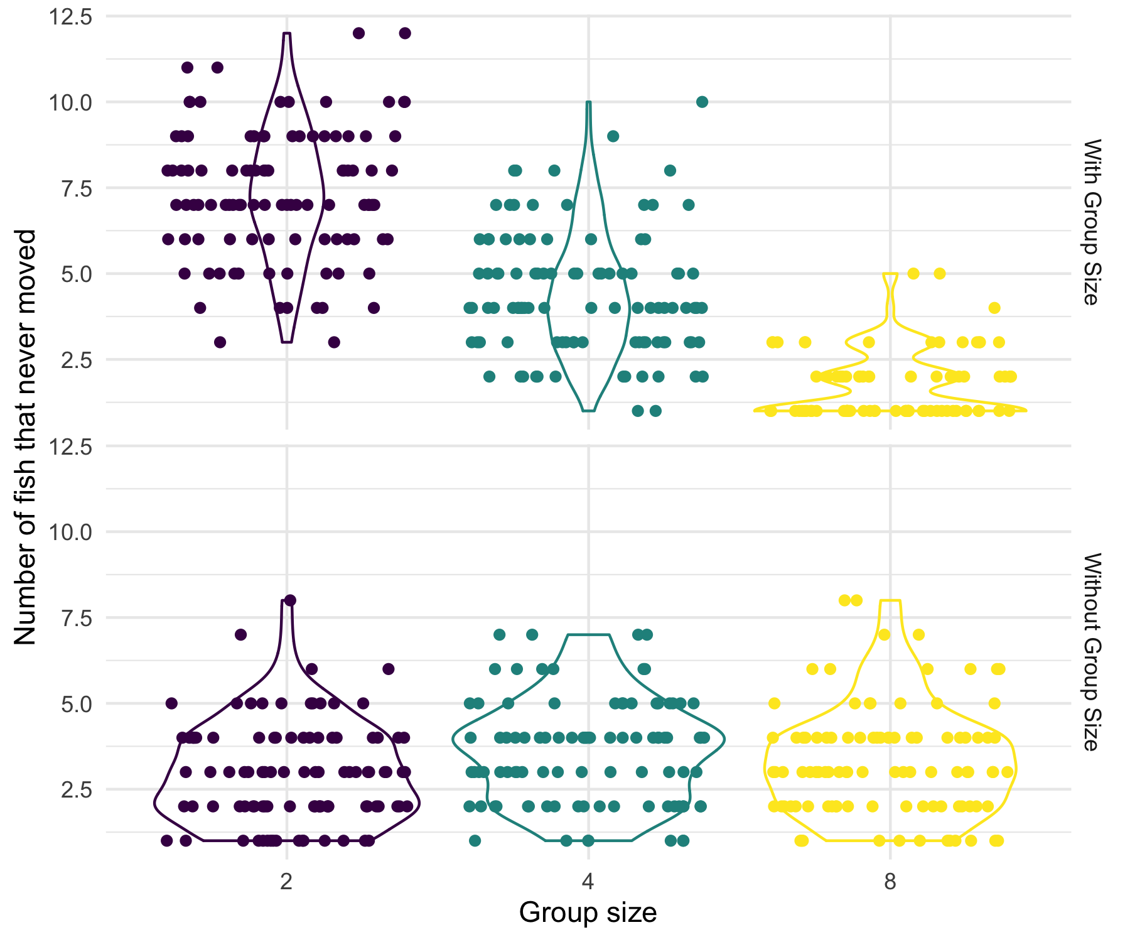

### Known Food

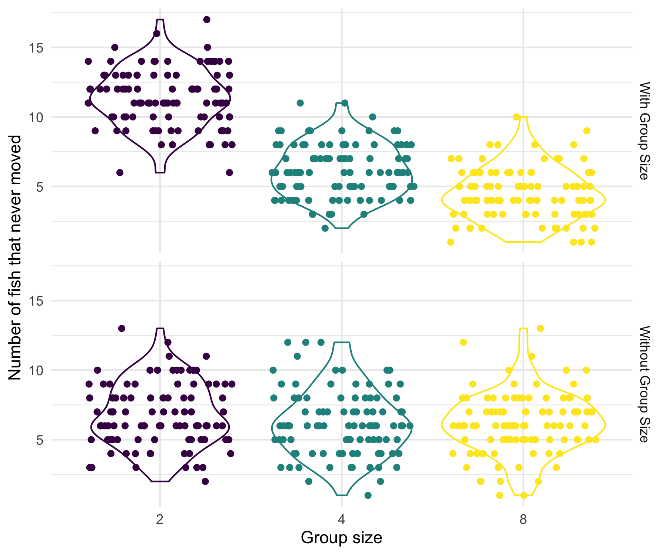

### Novel Food

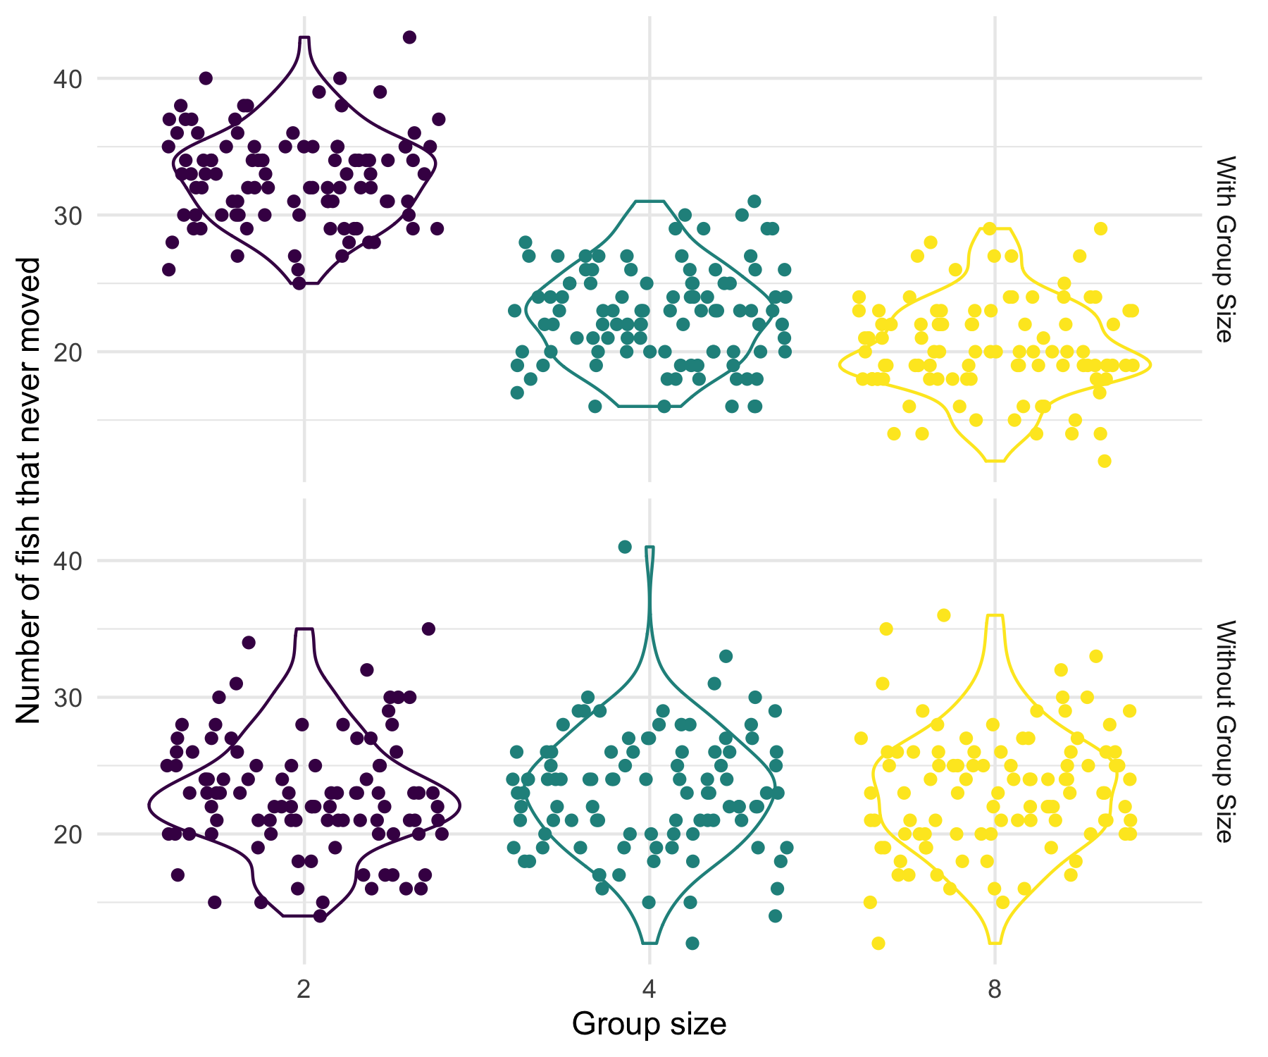

## Plateau Plots

### Predator Cue

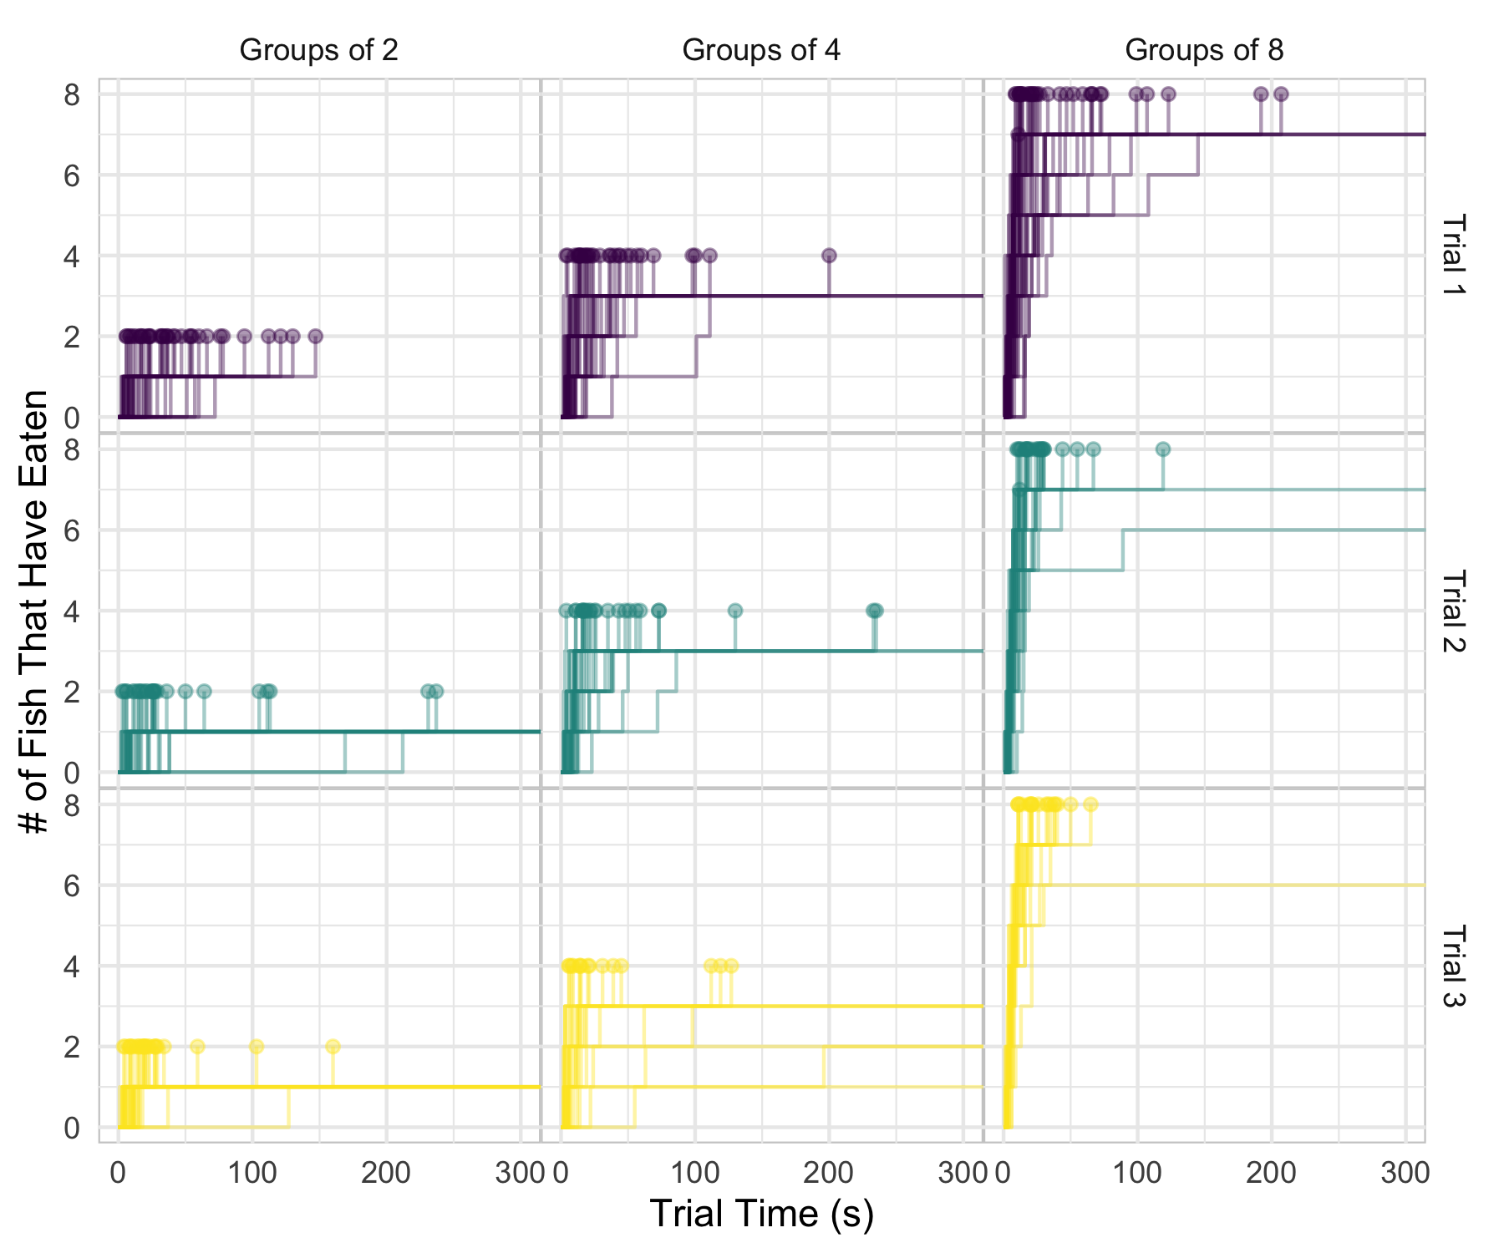

### Known Food

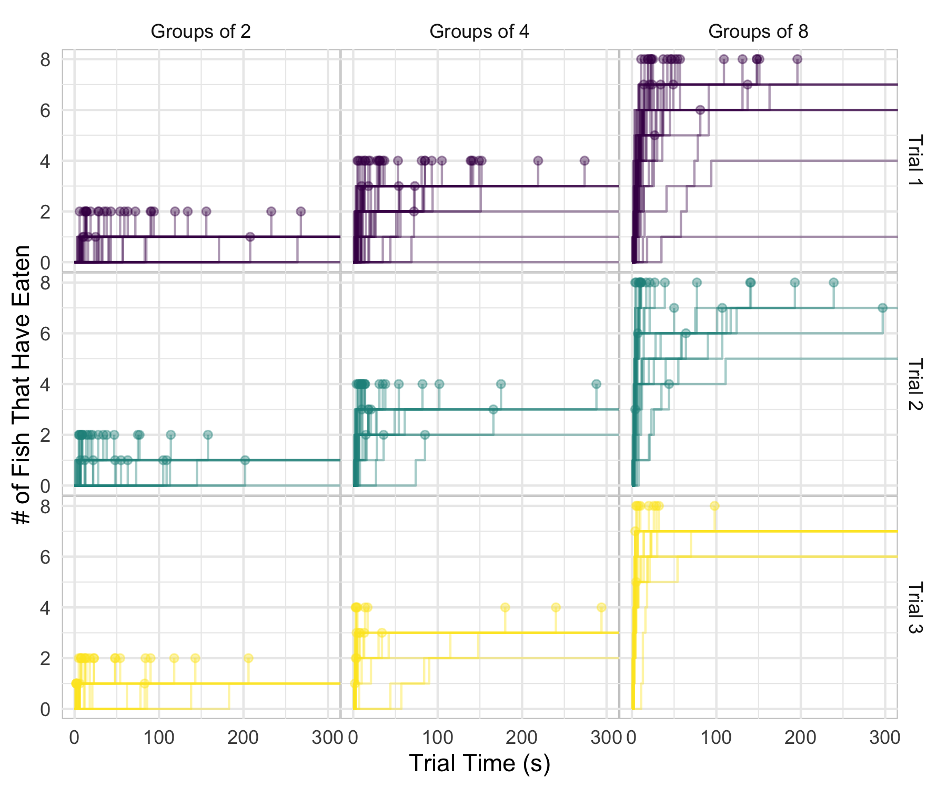

### Novel Food

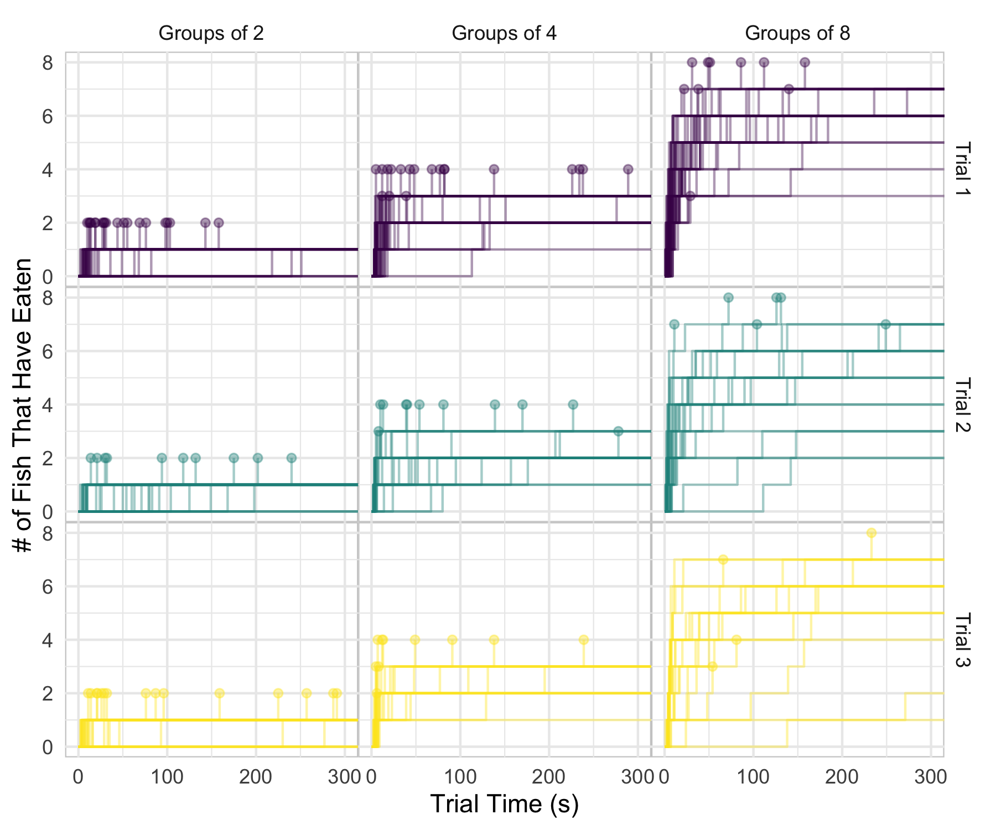

## First and Last per Group

### Pred Cue

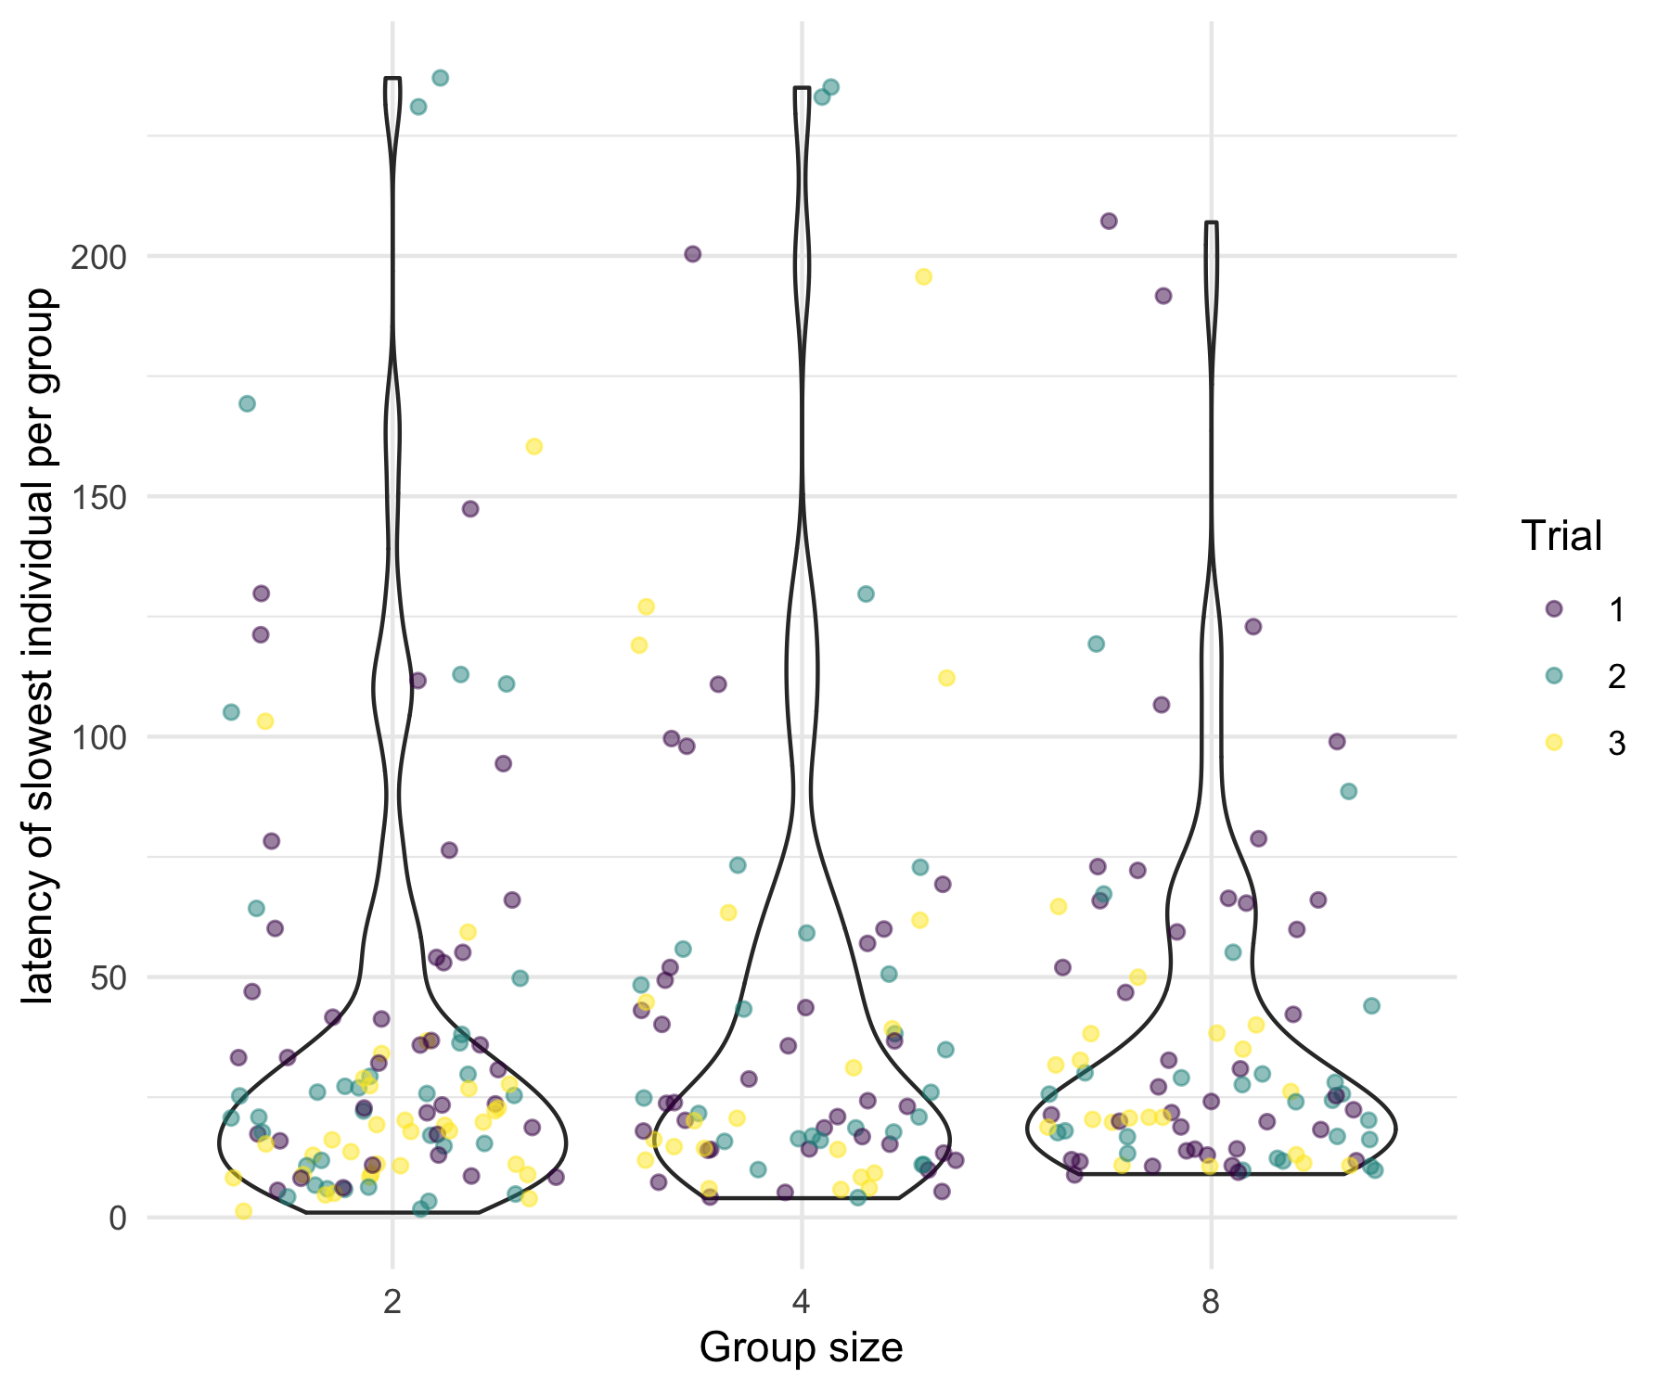

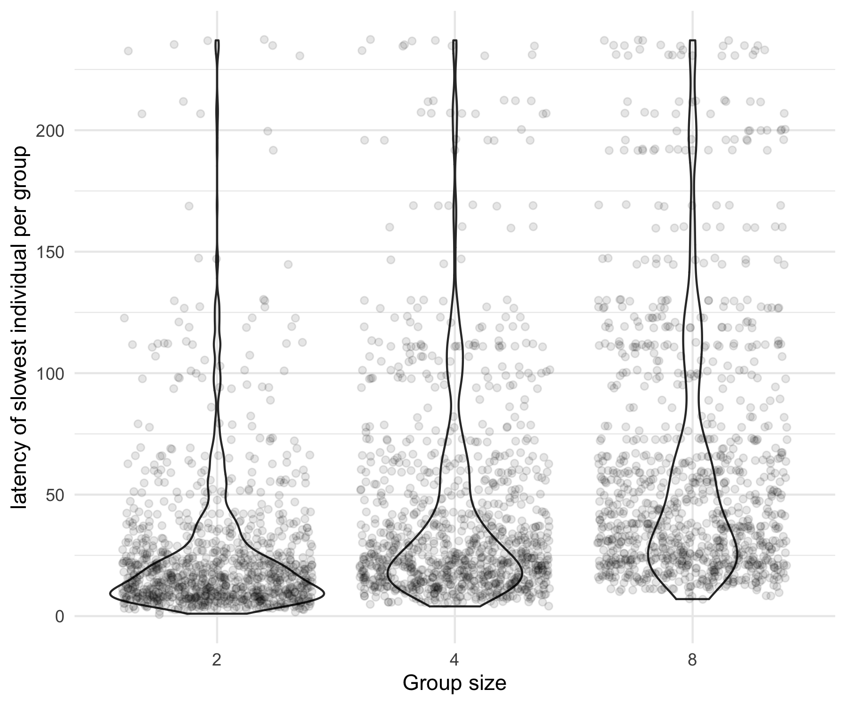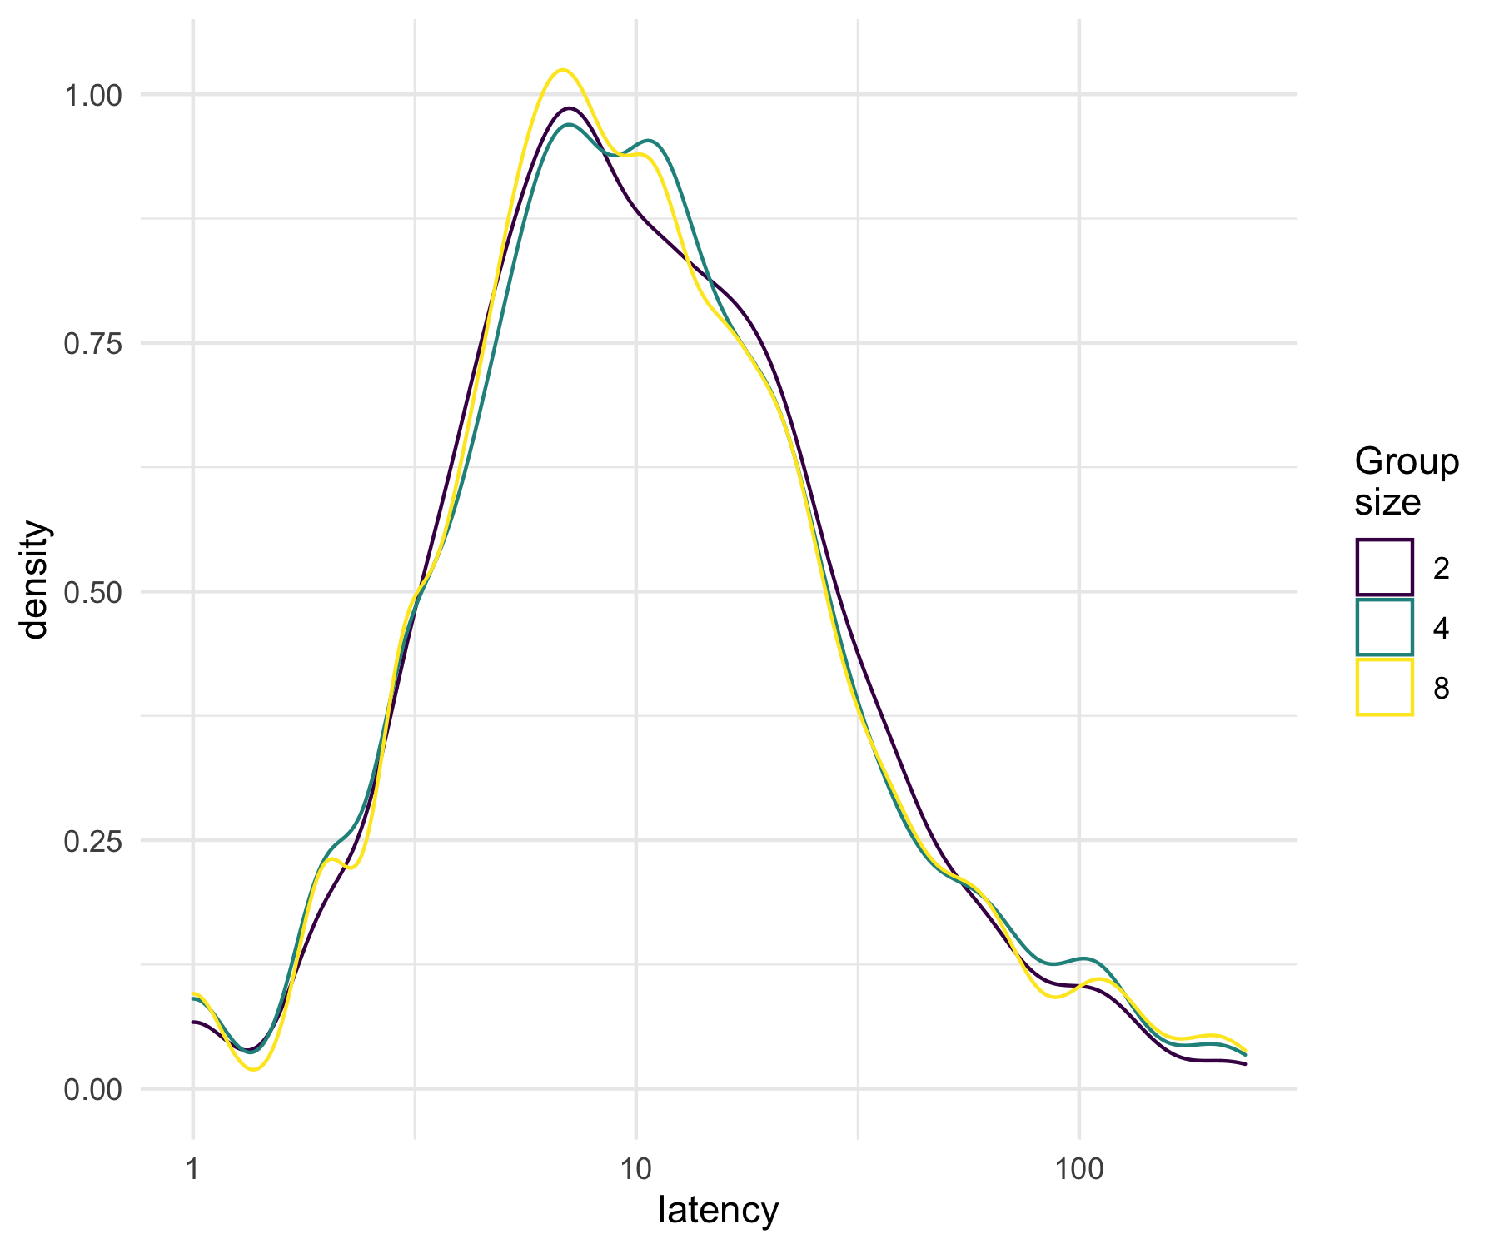

### Known Food

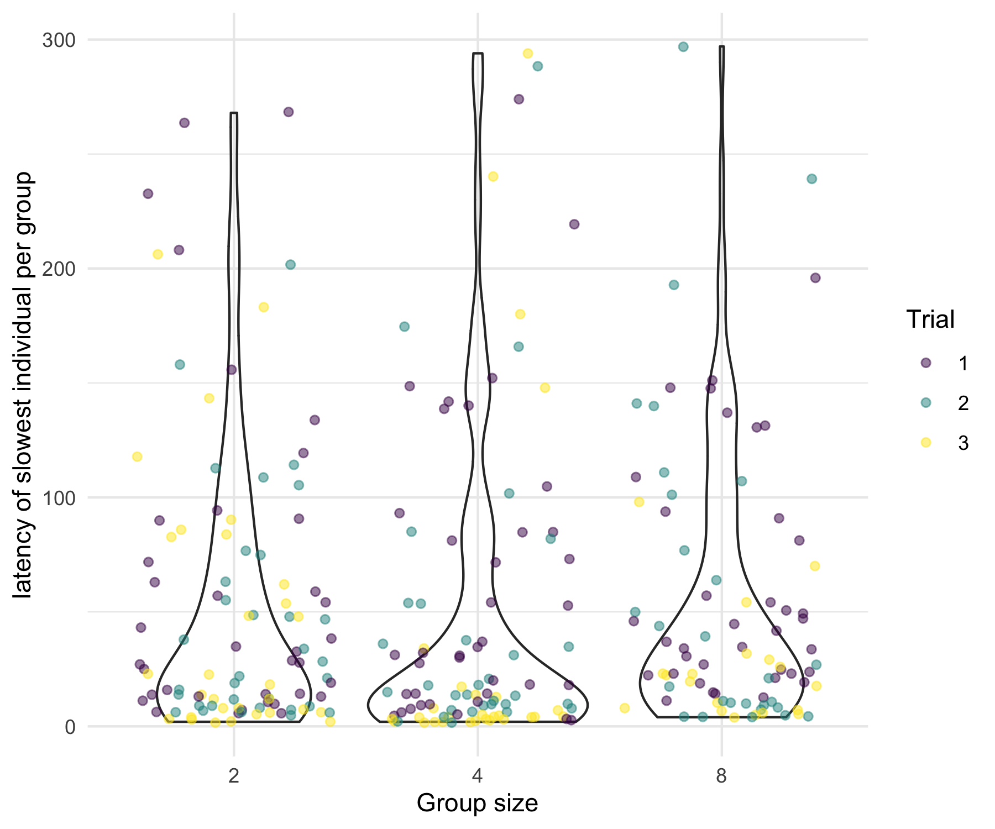

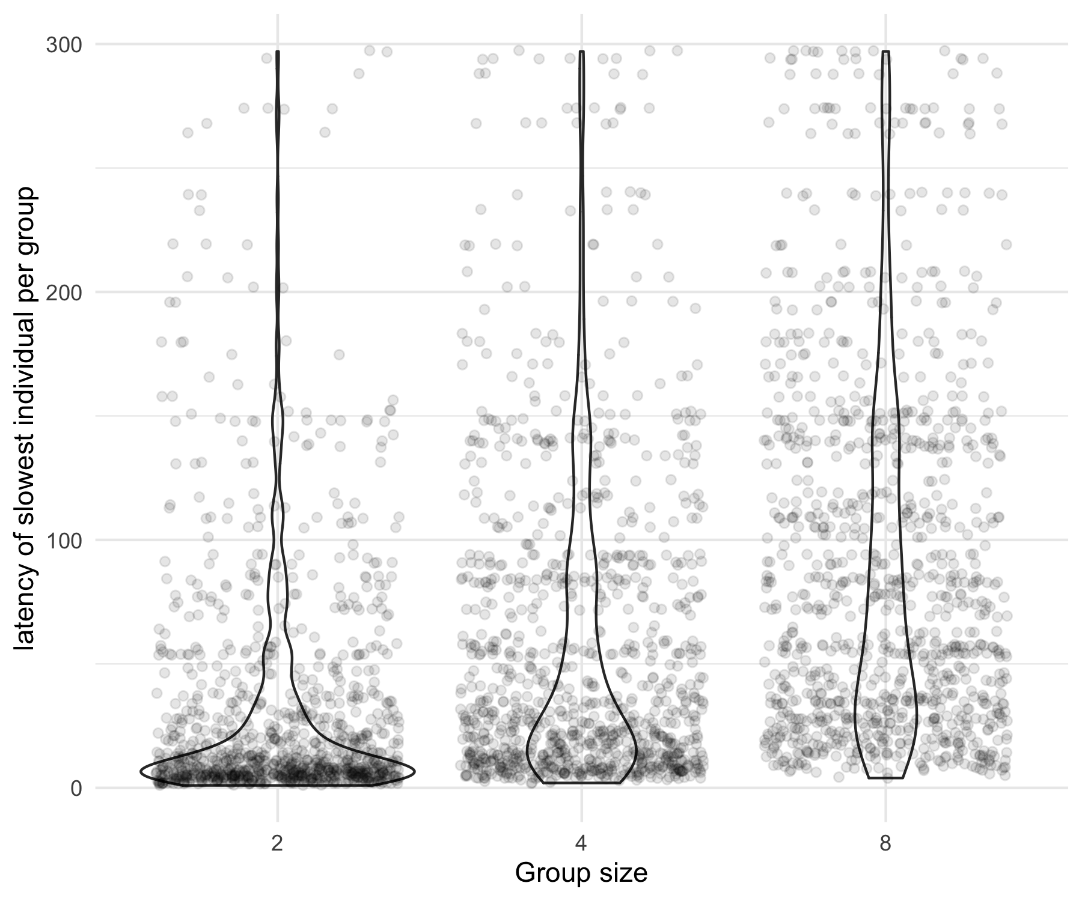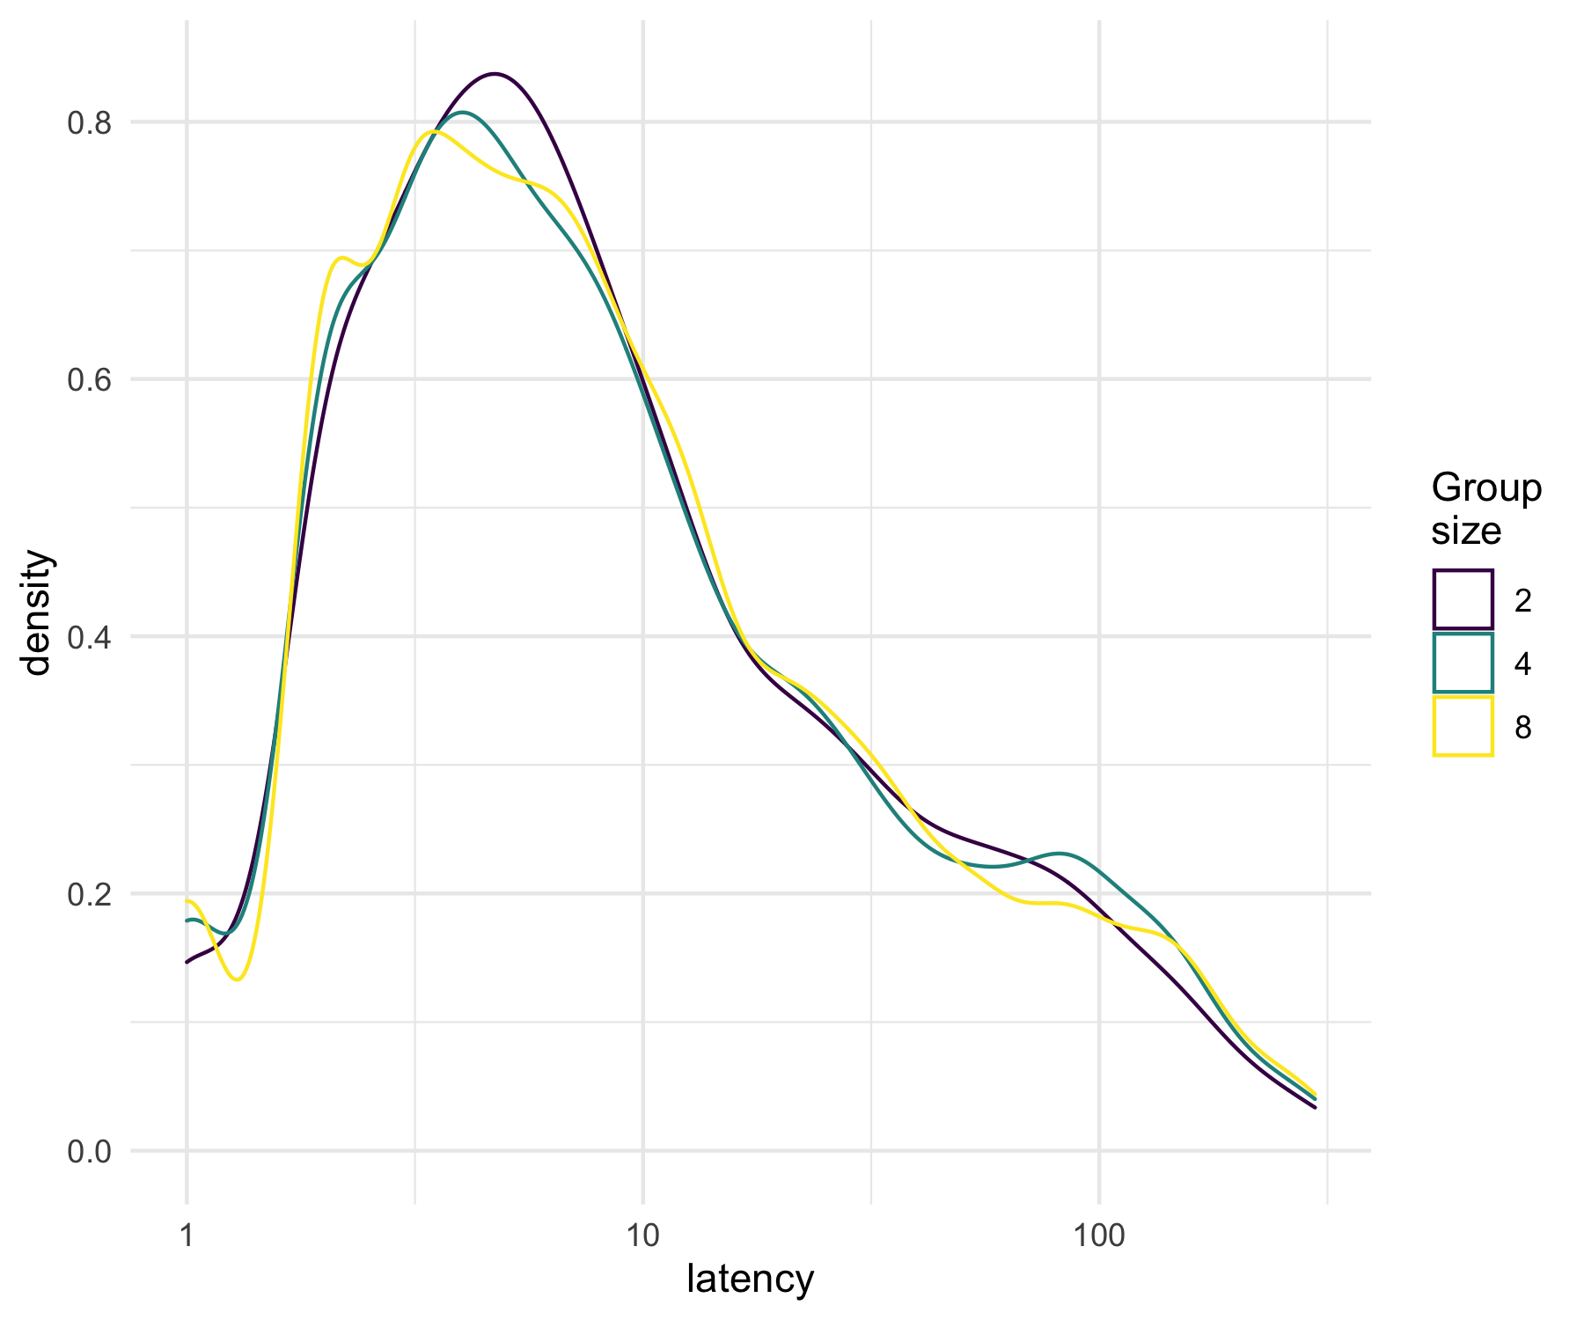

### Novel Food



